# ABSTRACT

**CHAPTER 1**

## INTRODUCTION

Now day’s an android phone is play the important role in every one’s life.And the now day’s every one can travels one place to another place as per the need.For that we required some resources like car, bus, etc.

A car is usually an electro-mechanical machine that is guided by computer and electronic programming. The car which can be controlling using an APP for android mobile. We are developing the remote buttons in the android app by which we can control the car motion with them. Here we use Wi-fi communication to interface controller and android. Controller can be interfaced to the Wi-fi module though UART. According to commands received from android the robot motion can be controlled. The consistent output of a robotic system along with quality and repeatability are unmatched.

# INTRODUCTION

A robot is a mechanical or virtual artificial agent, usually an electromechanical machine that is guided by a computer program or electronic circuitry. The first digital and programmable Robot was invented by George Devol in 1954 and was named the Unimate[1]. Apps control robot is one where the controlling is done by the smartphone apps using Bluetooth. It is possible to control of different parameters of many applications such as to control the speed, light, direction, sound and temperature. Nowadays smart phones are becoming more powerful with reinforced processors, larger storage capacities, richer entertainment function and more communication methods [2].Recently the Bluetooth technology has become the standard for device-to-device communications for short distance. Bluetooth is an open standard specification for a radio frequency (RF)- based, short-range connectivity technology that promises to change the face of computing and wireless communication. It is designed to be an inexpensive, wireless networking system for all classes of portable devices, such as laptops, PDAs (personal digital assistants), and mobile phones. The controlling device of the whole system is a microcontroller [3-4]. The rapid development of smart phone technology, especially the promotion and application of wireless technology, provides a platform and opportunity for some basic ideas and methods in the control theory to be applied to the car[11]. Automated smooth controlled cars are required for road safety of developing Bangladesh. Still, many traffic situations remain complex and difficult to manage, particularly in urban settings. The driving task belongs to a class of problems that depend on underlying systems for logical reasoning and dealing with uncertainty[12]. So, to move vehicle computers beyond monitoring and into tasks related to environment perception or driving, we must integrate aspects of human intelligence and behaviours so that vehicles can manage driving actuators in a way similar to humans[16].

# NEED OF PROJECT

* + - We know that, Electric vehicles use electricity to charge their batteries instead of using fossil fuels like petrol or diesel. Electric vehicles are more efficient, and that combined with the electricity cost means that charging an electric vehicle is cheaper than filling petrol or diesel for your travel requirements.
    - In this project we controlling Electric car using wirelessly through Android smart phone using the Wi-fi module through UART protocol with the Robotic mechanism[16].So, user can control the Electric car from anywhere within the rang of controlled

# AIM OF THE PROJECT

* + - The aim of this project to designing a ROBOTI car that can be operated wirelessly through Wi-fi communication using Android Apps on smart phone.
    - To avoid the vehicle/car accident by using the different-different sensor models.

# OBJECTIVES OF THE PROJECT

* To control the car with help of Android phone.
* Drive the car/vehicle safely and with the security.
* Avoid the Accidental cases.
* Maintain the Environmental balance(with ECO-friendly).

# LITERATURE SURVEY:

Intelligent Transport Systems (ITS) based on Internet of Things (IoT) are getting popular and can be seen as a solution to improve the road safety. One effective technique to reduce traffic hazards and save precious lives could be to reduce the response time after an accident has occurred.

Some systems focus on preventive strategy because at the end, goal is to save lives. This system particularly focuses on the safety of two wheelers and checks if the driver is drowsy

Many of the researchers have worked to bring the automation in the automobile field.Few of them are summarised here.

* The authors have developed a system for the remote controlling of a vehicle using the 8051 microcontroller technology in which author are able to control the car using the android app.
* The authors have developed a system for the Smartphone control robots through bluetooth using the Bluetooth technology in which author are able to control using the bluetooth. In which the user used the Bluetooth module for that project which is used to control the through the Smartphone.
* The authors have developed the Bluetooth operated robot vehicle using mobile android app which is used to control the vehicle through the android phone using the android app The authors have developed the Bluetooth based android controlled robot using the bluetooth module.
* The authors publish the research paper in which the author is developed one system which is “The DLR lightweight robot: design and control concepts for robots in human environments” .Based on the design and control of robot.
* The authors have developed the Obstacle avoidance and Android mobile phone controlled Bluetooth robot using arduino. In which the Author is works on the Arduino board and ultra-Sonic components.

There are no. of authors work on this topic of robot which are shows in the below comparison table as following :-

# COMPARISON TABLE:

**Table 1: Comparison of Existing Systems**

|  |  |  |  |  |  |
| --- | --- | --- | --- | --- | --- |
| **Sr. No** | **Authors** | **Paper Title** | **Publisher** | **Year** | **Method Used** |
| 1 | Dickmanns E | The development of machine vision for road vehicles in the last decade | IEEE | 2002 | B a s e d o n V e h i c l e c o n t r o l algorithms |
| 2. | Schaffer A A,  Haddadin S, Ott Ch, Stemmer A,  Wimbock T and  Hirzinger G | T h e D L R  lightweight robot: design and control  concepts for robots  in human environments | I n d u s t r i a l R o b o t : A n Inter national  Journal s | 2007 | B a s e d o n  d e s i g n a n d c o n t r o l o f  robot |
| 3. | H e b a h H O Nasereddin and Abdelkarim A | S m a r t p h o n e control robots through bluetooth | IJRRAS | 2010 | B a s e d o n Bluetooth |
| 4. | Zi-Yi, Lam, Sew- Kin, Wong, Wai- L e o n g , P a n g , Chee-Pun, Ooi | The Design of DC Motor Driver for Solar Tracking Applications | IEEE | 2012 | B a s e d o n M i c r o - c o n t r o l l e r DC-DC buck  converter |

|  |  |  |  |  |  |
| --- | --- | --- | --- | --- | --- |
| 5. | M a l i k A,Shrivastava A,Singh GK,Shuk A | R e m o t e controlling of a v e h i c l e u s i n g android app | Int. J of Res. in Eng. & Adv. Tech. & Sci | 2015 | B a s e d o n 8051Microco n t r o l l e r technology |
| 6. | P a r m a r D , Tripathi D, Sahni A, Singh P | Bluetooth operated robot vehicle  u s i n g m o b i l e android app | Int. J of Res. i n E n g . & Adv Technol | 2015 | B a s e d o n Bluetooth |
| 7. | Ashima, Kumar R, Nikhil T, Singh P | O b s t a c l e a v o i d a n c e a n d Anderoid mobile phone controlled Bluetooth robot  using arduino | IJEEE | 2015 | B a s e d o n Arduino and Ultra-sonic |
| 8. | E s h i t a R Z ,  Barua T, Barua A | Bluetooth based android controlled | A m e r i c a n  J o u r n a l o f | 2016 | B a s e d o n Bluetooth |
| 9. | G a n d o t r a S ,  S h a r m a B ,  M a h a j a n S ,  M o t u p T ,  Choudhary T and  Thakur P | B l u e t o o t h  controlled RC  c a r u s i n g  Arduino | I m p . J o f  Interdisciplin-ary Research  (IJIR) | 2016 | Based on  A r d u i n o  control |

|  |  |  |  |  |  |
| --- | --- | --- | --- | --- | --- |
| 10. | N K u m a r , D Acharya and D Lohani | An Iot – based vehical accident d e t e c t i o n c l a s s i f i c a t i o n system using senor  fusion | IEEE | 2020 | Based on Iot |
| 11 | KL Narayanan and CRS Ram | IoT based smart accident detection & i n s u r a n c e  claiming system | IEEE | 2021 | Based on GUI and Bluetooth |
| 12. | SR Prasath, RS Krishnan and SM Priya | IoT based Smart A c c i d e n t Detection System for Hit and Run Cases | IEEE | 2022 | B a s e d o n Arduino based control unit |

# 6. PLANNING

**Table 2: Planning**

|  |  |  |
| --- | --- | --- |
| **Sr. no.** | **Month** | **Task** |
| 1 | July 2022 | * Formed the group. * Did the survey on problems related to renewable energy sources. * Found out the problems faced by the people. * Discussed different ideas with Guide related to Agriculture, Robotics, and Embedded. * We submitted 3 project ideas.  1. Android Controlled Robot Car 2. IOT based Green House Farming. 3. Women safety with GPS tracking and alerts using arduino. |
| 2. | August 2022 | * Given the presentation on the above three project topics * Final topic was selected : Android Controlled Robot Car. * Gave presentation on final topic. * Suggestions are given by the teachers. |
| 3. | September 2022 | * Literature survey * Block diagram implementation * Finalisation of components, downloading of datasheet of each component used for the project. |
| 4. | October 2022 | * Circuit diagram design. * Designed the Flowchart. |

|  |  |  |
| --- | --- | --- |
| 5. | November 2022 | * Simulation on TinkerCAD simulation software. * To find the solutions for generated problems like how to avoid the obstacle in front of car, controlling issue of the caret * Layout |
| 6. | December 2022 | * Preparation of Synopsis report. |

# CHAPTER 2 HARDWARE DESIGN

* 1. **BLOCK DIAGRAM**

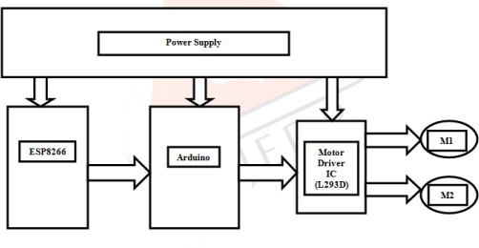

# Fig.:2.1 A) Block Diagram

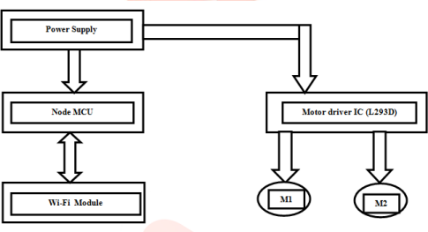

**Fig.:2.1 B) Block Diagram**

# BLOCK DIAGRAM DESCRIPTION:

Above block diagram show the actual working of the Android controlled Robot car. As shown in fig. We can control the robot car by the help of Android phone. As the connection shows in fig. The Android phone is connected to the microcontroller by the help of Wireless module to send the instruction to the microcontroller to control the speed and direction of car. And the microcontroller is connected to the Motor Driver IC and then Motor Driver IC is connected to the Motor.

# COMPONENTS REQUIRED:

* + 1. **NodeMCU:**

**NodeMCU** is a low-cost open source IoT platform[9][10].It initially included firmware which runs on the ESP8266 Wi-Fi SoC from Espressif Systems, and hardware which was based on the ESP-12 module[11][12]. Later, support for the ESP32 32- bit MCU was added.

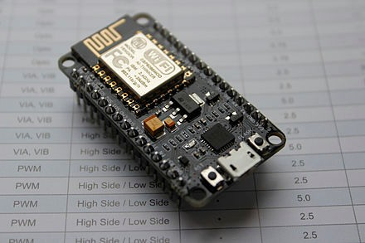

## Fig.2.2.1:A) NodeMCU

NodeMCU was created shortly after the ESP8266 came out. On December 30, 2013, Espressif Systems[11]began production of the ESP8266[13].NodeMCU started on 13 Oct 2014, when Hong committed the first file of nodemcu-firmware to GitHub[14]. Two months later, the project expanded to include an open-hardware platform when developer Huang R committed the gerber file of an ESP8266 board, named devkit v0.9[15].Later that month, Tuan PM ported MQTT client library from Contiki to the ESP8266 SoC platform, [16]and committed to NodeMCU project, then NodeMCU was able to support the MQTT IoT protocol, using Lua to access the MQTT broker. Another important update was made on 30

Jan 2015, when Devsaurus ported the u8glib[17] to the NodeMCU project,[18]enabling NodeMCU to easily drive LCD, Screen, OLED, even VGA displays.

In the summer of 2015 the original creators abandoned the firmware project and a group of independent contributors took over. By the summer of 2016 the NodeMCU included more than 40 different modules.

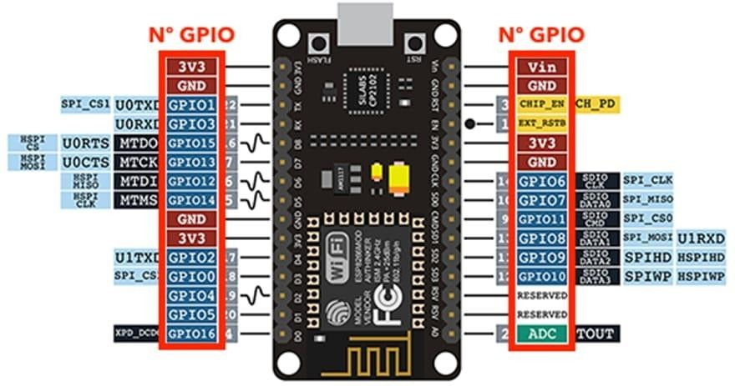

# Fig.2.2.1:B) NodeMCU

**Features:**

# Node-MCU Specifications:

The Node MCU is available in various package styles. Common to all the designs is the base ESP8266 core. Designs based on the architecture have maintained the standard 30- pin layout. Some designs use the more common narrow (0.9″) footprint, while others use a

wide (1.1″) footprint – an important consideration to be aware of.The most common models of the NodeMCU are the Amica (based on the standard narrow pin-spacing) and the LoLin which has the wider pin spacing and larger board. The open-source design of the base ESP8266 enables the market to design new variants of the Node-MCU continually.

# Node-MCU Technical Specifications:

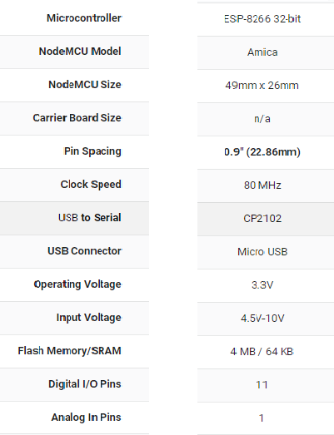

* + 1. **L298N Motor Driver Modul**e**:**

A motor driver module is a simple circuit used for controlling a DC motor. It is commonly used in autonomous robots and RC cars (L2938N and L293D are the most regularly utilized motor driver chips). A motor driver module takes the low voltage input from a controller like Arduino. This input logic controls the direction of DC motors connected to the driver. To put it in simple words, you can control the direction of DC motors by giving appropriate logic to the motor driver module.

The motor driver module consists of a motor driver IC, which is the heart of the module. The IC alone can control the DC motor but using the module makes the interfacing with Arduino easy.

All microcontrollers operate on low-level voltage/current signals, unlike motors. For instance, the Arduino or PIC microcontroller can output a maximum voltage of 5V or 3.3V. But a decent DC motor needs at least 5V or 12V. Also, the output current limit of Arduino is relatively very low.

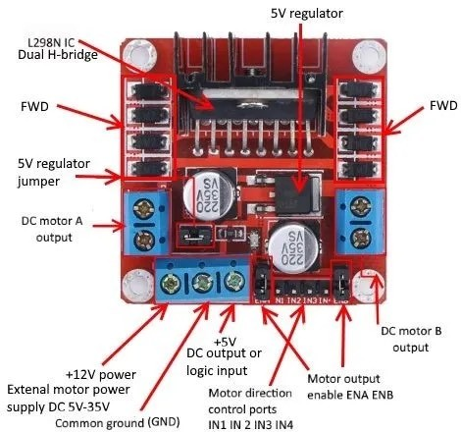Hence the output of Arduino is not enough to power up the motors. To solve this problem the use of a motor driver is essential. We bridge the gap between the Arduino and motor by introducing a motor driver between them. And to supply the voltage/current required to operate the motor, an external supply is connected to the motor driver module.

AVCOE, Sangamner

# Fig.2.2.2: A) L298N Motor Driver Module.

The L298N motor driver is based on the H-bridge configuration (an H-bridge is a simple circuit that lets us control a DC motor to go backward or forward.), which is useful in controlling the direction of rotation of a DC motor.

It is a high current dual **full H-bridge** driver that is constructed to receive standard TTL logic levels. It can also be used to control inductive loads e.g. **relays**, solenoids, motors (DC and stepping motor), etc.

This **L298N Motor Driver Module** is a high power motor driver module for driving DC and Stepper Motors. This module consists of an L298 motor driver IC and a 78M05 5V regulator. **L298N Module** can control up to 4 DC motors, or 2 DC motors with directional and speed control.The L298N Motor Driver module consists of an L298 Motor Driver IC, 78M05 Voltage Regulator, resistors, capacitor, Power LED, 5V jumper in an integrated circuit.78M05 Voltage regulator will be enabled only when the jumper is placed. When the power supply is less than or equal to 12V, then the internal circuitry will be powered by the voltage regulator and the 5V pin can be used as an output pin to power the microcontroller. The jumper should not be placed when the power supply is greater than 12V and separate 5V should be given through 5V terminal to power the internal circuitry.

ENA & ENB pins are speed control pins for Motor A and Motor B while IN1& IN2 and IN3 & IN4 are direction control pins for Motor A and Motor B

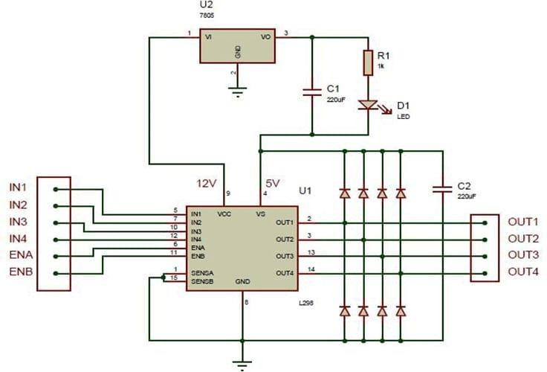

**Fig.2.2.2 B): Internal circuit diagram of L298N Motor Driver module.**

|  |  |
| --- | --- |
| **Pin Name** | **Description** |
| IN1 & IN2 | Motor A input pins. Used to control the spinning direction of Motor A |
| IN3 & IN4 | Motor B input pins. Used to control the spinning direction of Motor B |
| ENA | Enables PWM signal for Motor A |

|  |  |
| --- | --- |
| ENB | Enables PWM signal for Motor B |

|  |  |
| --- | --- |
| OUT1 & OUT2 | Output pins of Motor A |
| OUT3 & OUT4 | Output pins of Motor B |
| 12V | 12V input from DC power Source |
| 5V | Supplies power for the switching logic circuitry inside L298N IC |
| GND | Ground pin |

**Features:**

* Operating Supply Voltage Up to 46V.
* Total DC Current Up to 4A.
* Low Saturation Voltage.
* OverTemparature Protection.
* Logical “0” Input Voltage Up to 1.5V (High Noise Immunity)

# DC Motor:

A DC motor is any of a class of rotary electrical motors that converts direct current (DC) electrical energy into mechanical energy. The most common types rely on the forces produced by magnetic fields. Nearly all types of DC motors have some internal mechanism, either electromechanical or electronic.To periodically change the direction of current in part of the motor. DC motors were the first form of motor widely used, as they could be powered from existing direct-current lighting power distribution systems. A DC motor's speed can be controlled over a wide range, using either a variable supply voltage or by changing the strength of current in its field windings. Small DC motors are used in tools, toys, and appliances.

The Universal motor can operate on direct current but is a lightweight brushed motor used forportable power tools and appliances. Larger DC motors are currently used in propulsion of electric vehicles, elevator and hoists, and in drives for steel rolling mills. Working principle of DC motor is that When kept in a magnetic field, a current-carrying conductor gains torque and develops a tendency to move. In short, when electric fields and magnetic fields interact, a mechanical force arises. This is the principle on which the DC motors work.

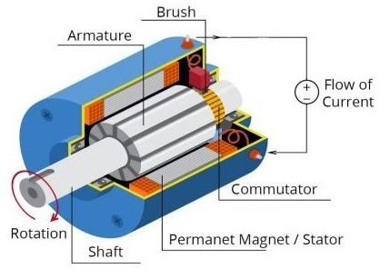

# Fig2.2.3:A) DC Motor.

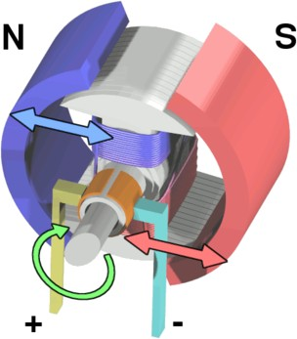

**Fig.2.2.3:B)Electromagnetic Motor.**

# Ultrasonic Sensor:

Ultrasonic sensors use sound to determine the distance between the sensor and the closest object in its path. How do ultrasonic sensors do this? Ultrasonic sensors are essentially sound sensors, but they operate at a frequency above human hearing.

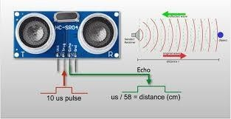

# Fig.2.2.4:A) UltraSonic sensor

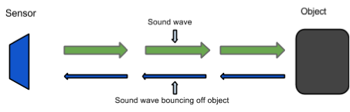

**Fig.2.2.4:B) Actual Working of UltraSonic sensor**

The sensor sends out a sound wave at a specific frequency. It then listens for that specific sound wave to bounce off of an object and come back (Fig. 2.2.4:B). The sensor keeps track of the time between sending the sound wave and the sound wave returning. If you know how

fast something is going and how long it is traveling you can find the distance traveled with equation 1.

**Equation 1.** *d* = *v*×*t*

# HCSR04 Specifications :

* Power Supply: +5V DC
* Quiescent Current: <2mA
* Working current: 15mA
* Effectual Angle: <15o
* Ranging Distance: 2400 cm
* Resolution: 0.3 cm Measuring Angle: 30o
* Trigger Input Pulse width: 10uS
* Dimension: 45mm x 20mm x 15mm
* Weight: approx. 10 g

# 9_Volt Battery:

The **nine-volt battery**, or **9-volt battery**, is an electric battery that supplies a nominal voltage of 9 volts. Actual voltage measures 7.2 to 9.6 volts, depending on battery chemistry. Batteries of various sizes and capacities are manufactured; a very common size is known as PP3, introduced for early transistor radios. The PP3 has a rectangular prism shape with rounded edges and two polarized snap connectors on the top. This type is commonly used for many applications including household uses such as smoke and gas detectors, clocks, and toys[17].

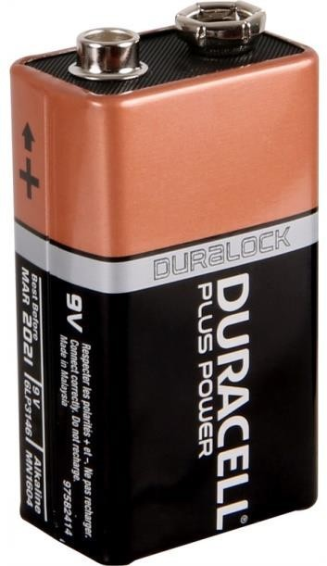

# Fig.2.2.5:9_Volt Battery

A rechargeable battery is a type of electrical battery which can be charged, discharged into a load, and recharged many times, as opposed to a disposable or primary battery, which is supplied fully charged and discarded after use.

# General Features

* + - * Can be mounted in any orientation.
      * Computer designed lead, calcium tin alloy grid for high power density.
      * Long service life, float or cyclic applications.
      * Maintenance-free operation.
      * Low self discharge.

# Light-Emitting Diode:

LED, in full light-emitting diode, in electronics, a semiconductor device that emits infrared or visible light when charged with an electric current. Visible LEDs are used in manyelectronic devices as indicator lamps, in automobiles as rear-window and brake lights, and on billboards and signs as alphanumeric displays or even full-colour posters. Infrared LEDs are employed in autofocus cameras and television remote controls and also as light sources in fibre optic telecommunication systems.

The familiar light bulb gives off light through incandescence, a phenomenon in whichthe heating of a wire filament by an electric current causes the wire to emit photons, the basic energy packets of light. LEDs operate by electroluminescence, a phenomenon in which the emission of photons is caused by electronic excitation of a material. The material used most often in LEDs is gallium arsenide, though there are many variations on this basic compound, such as aluminum gallium arsenide or aluminum gallium indium phosphide. The brightnessof the light observed from an LED depends on the power emitted by the LED and on the relative sensitivity of the eye at the emitted wavelength. Maximum sensitivity occurs at 0.555 micro metre, which is in the yellow-orange and green region. The applied voltage in most LEDs is quite low, in the region of 2.0 volts; the current depends on the application and ranges from a few mill iamperes to several hundred mill iamperes.

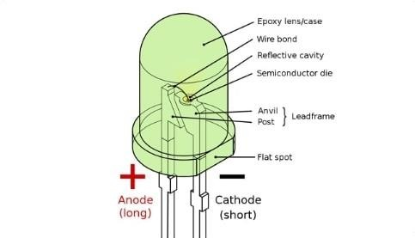

# Fig.2.2.6: Light-Emitting Diode.

* + 1. **Jumper Wires:**

A jump wire (also known as jumper, jumper wire, DuPont wire) is an electrical wire, or group of them in a cable, with a connector or pin at each end (or sometimes without them

–simply "tinned"), which is normally used to interconnect the components of a breadboard or other prototype or test circuit, internally or with other equipment or components, without soldering. Individual jump wires are fitted by inserting their "end connectors" into the slots provided in a breadboard, the header connector of a circuit board, or a piece of test equipment. Jumper wires are simply wires that have connector pins at each end, allowing them to be used to connect two points to each other without soldering. Jumper wires are typically used with breadboards and other prototyping tools in order to make it easy to change a circuit as needed.

There are different types of jumper wires. Some have the same type of electrical connector at both ends, while others have different connectors. Some common connectors are:

* Solid tips – are used to connect on/with a breadboard or female header connector. The arrangement of the elements and ease of insertion on a breadboard allows increasing the mounting density of both components and jump wires without fear of

short-circuits. The jump wires vary in size and colour to distinguish the different working signals.

* Crocodile clips – are used, among other applications, to temporarily bridge sensors, buttons and other elements of prototypes with components or equipment that have arbitrary connectors, wires, screw terminals, etc.
* Banana connectors – are commonly used on test equipment for DC and low- frequency AC signals.
* Registered jack (RJnn) – are commonly used in telephone (RJ11) and computer networking (RJ45).
* RCA connectors – are often used for audio, low-resolution composite video signals, or other low-frequency applications requiring a shielded cable.
* RF connectors – are used to carry radio frequency signals between circuits, test equipment, and antennas.
* 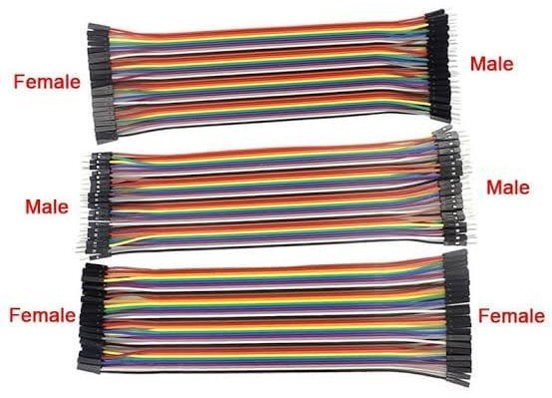RF jumper cables - Jumper cables is a smaller and more bendable corrugated cable which is used to connect antennas and other components to network cabling. Jumpers are also used in base stations to connect antennas to radio units. Usually the most bendable jumper cable diameter is 1/2".

# Fig.2.2.7:Jumper Wires

* + 1. **RELAY:**

Relays are electromechanical switches. They have very high current rating and both AC and DC motors can be controlled through them because motor will be completely isolated from the remaining circuit. Relays are used as driving circuit for motor, they are used

to rotate the motor in forward or reverse direction. Each motor uses two relays hence there are total 6 relays connected to pins of microcontroller which are 20-24.

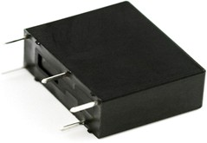

## Fig.2.2.8:A) Relay

* + - * **Normally Open (NO):** Contacts connect the circuit when the relay is activated, the circuit is disconnected when the relay is inactive.
      * **Normally Closed (NC):** Contacts disconnect the circuit when the relay is activated, the circuit is connected when the relay is inactive.
      * **ChangeOver (CO):** It’s the common contact.
      * **Coil:** It’s the electromagnet coil inside relay.

## Relay ratings:

* + - * **Coil rating:** It’s the Voltage at which the coil gets fully activated. Some also have coil resistance mentioned on them. Relay coil voltage rated 6V and 12V are the most commonly available.
    1. **DIODE:**

A diode is a two terminal electronic component that conducts primarily in one direction. It has low resistance to the current in one direction and high resistance in other. The most common function of a diode is to allow an electric current to pass in one direction while blocking current in the opposite direction. This unidirectional behaviour is called rectification and it is used to convert ac to dc. Here we use 1N4007 diodes.

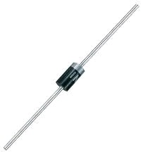

# Fig.2.2.9: 1N4007 Diode

* + 1. **CAPACITOR:**

Capacitor is a passive 2 terminal electrical component that stores electrical energy when they are connected to battery or some other charging circuit. The effect of capacitor is known as capacitance. The capacitor contains 2 metallic plates that are separated by some form of insulation. Capacitance is usually measured in the farad unit. They are commonly placed in electronic components and are used to maintain a power supply while the device is unplugged and without a battery for a short time.

Here, in our project we are using 0.1uf, 100uf, 450uf, 470uf.

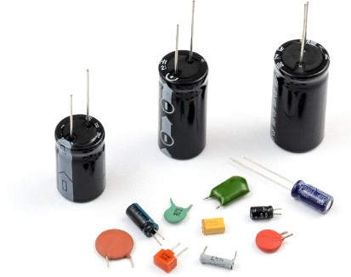

# Fig.2.2.10: Capacitors

* + 1. **RESISTORS:**

A resistor is a passive two-terminal electrical component that implements electrical resistance as a circuit element. Resistors act to reduce current flow, and, at the same time, act to lower voltage levels within circuits. Here, in our project we are using 10Ω, 1kΩ, 2.2KΩ and 10KΩ.



# Fig.2.2.11: (a) resistor (b) rheostat (variable resistor) and (c) potentiometer

* 1. **CIRCUIT DIAGRAM:**

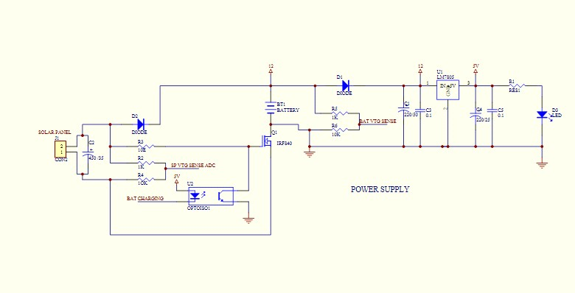

# Fig.2.3.1: Circuit Diagram of Power Supply

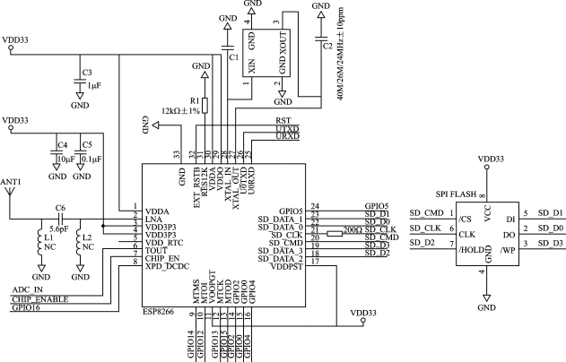

**Fig.2.3.2: Circuit Diagram of controller**

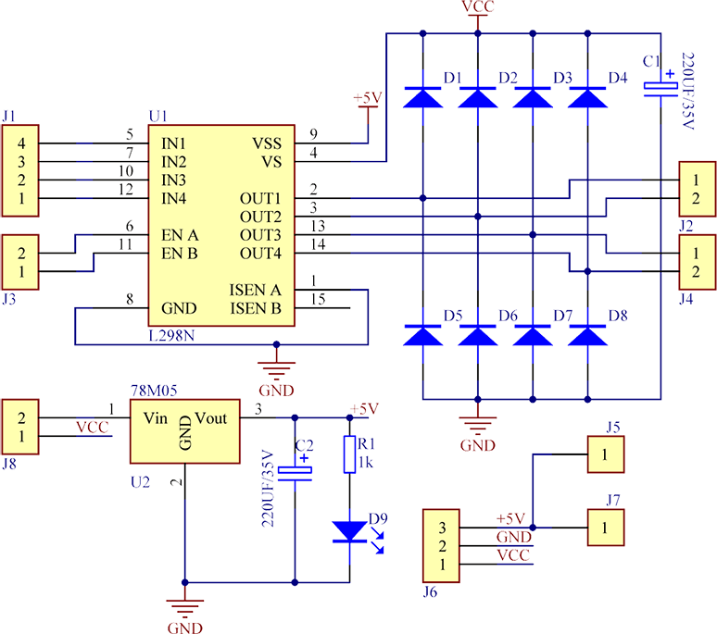

# Fig.2.3.3: Circuit Diagram of L298N Motor Driver

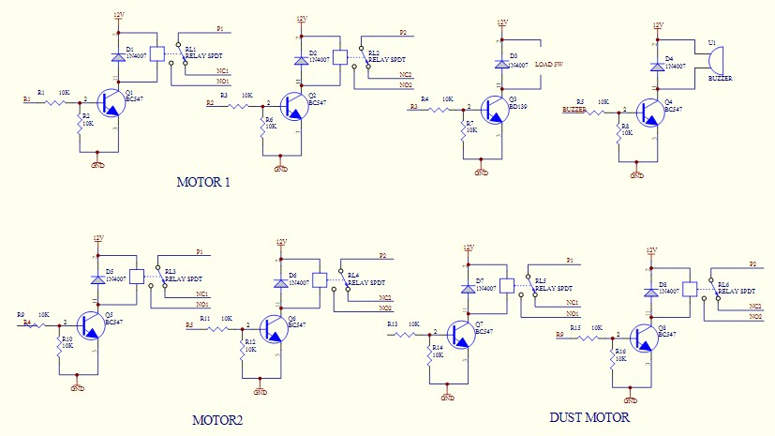

**Fig.2.2.4: Circuit Diagram of Relay**

# CHAPTER 3

* 1. **ALGORITHM**

# Algorithm of Nodemcu

Step 1: Start.

Step 2: Initialize connection

Step 3: get the input from Android app.

Step 4: send the signal to the motor driver ic. Step 5: received the input from ultrasonic sensor. Step 6: stop

# Algorithm for motor Driver IC

Step 1: Start.

Step 2: receive the input from node mcu. Step 3: send the power to the motor.

Step 4: control the rotation speed.

Step 5: control the motor direction ex. Backward or forward Step 6: stop.

# Algorithm for ultrasonic sensor

Step 1: Start.

Step 2: send the ultrasonic waves.

Step 3: received the waves after some micro time. Step 4: change in resistance.

Step 5: send the signal to the node-mcu. Step 6: Stop.

# Algorithm for All project

|  |  |
| --- | --- |
| Step 1: | Start. |
| Step 2: | Initialize connection of node-mcu. |
| Step 3: | get the input from Android app. |
| Step 4: | send the signal to the motor driver ic. |
| Step 5: | received the input from ultrasonic sensor. |
| Step 6: | if (1) stop car. |
| Step 7: | else send signal to the motor driver ic |
| Step 8: | control motor direction speed . |
| Step 9: | drive the car using the android . |
| Step 10: | stop car. |
| Step 11: | disable connection. |
| Step 12: | Stop. |

* 1. **FLOWCHART**

# Flowchart of Motor Driver IC

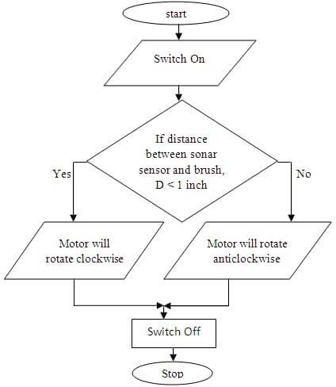

**Fig.3.2.1: Flowchart of Motor Driver IC**

# Flowchart for Ultrasonic Sensor

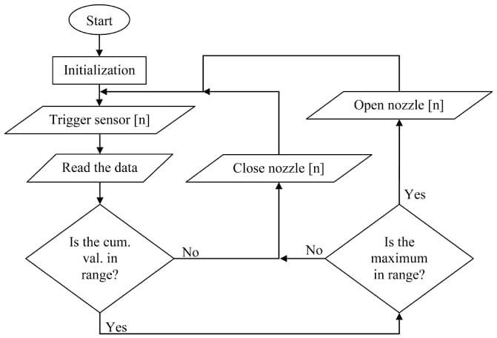

**Fig.3.2.2: Flowchart of Ultrasonic Sensor**

# Flowchart of Robotic Car

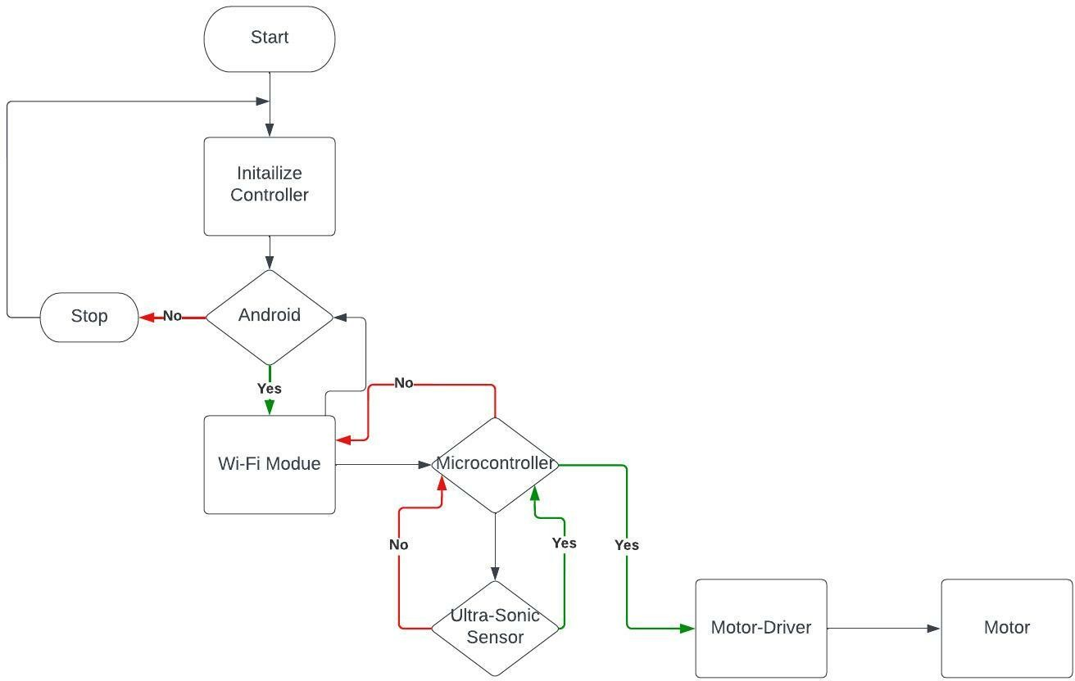

**Fig.3.2.3: Flowchart of Robotic Car**

# CHAPTER 4

**SYSTEM OVERVIEW**

# ADVANTAGES

* + - The use of automated shipping trucks will impact the world’s economy.
    - Robotic cars increase the car efficiency & speed.
    - Self-driving cars will improve the traffic conditions and congestion.
    - Inter vehicle communication.
    - Traffic signal notification.
    - Driver assistance.
    - Quick accident notifications .
    - Increased security (Live tracking).

# DISADVANTAGES:

* + - High Cost.
    - Every time need of Internet.
    - It works in the range of Wi-Fi only.

# APPLICATIONS:

* For transportation.
* It is robust, sensitive and fast moving, hence can be applied in rescue operations.
* Android control car can use for Army transportations also in the red alert areas.

# CHAPTER 5

**CONCLUSION:**

After completing this project we will conclude the following conclusion:

To us the need of internet and the things which are internet based are very much important nowadays. IOT or internet of things is the very important part in both computer and our daily lives. The above model describes how the arduino programs the car motor module and by IoT we actually rotate the wheels and give direction to the car. IoT gives us the opportunity to work with different platforms and it helps us to create various interesting modules to work on. We also tested the applications used to drive the car. Due to the new concept of Wireless Controlled Car using Bluetooth, Wifi and IOT, we were able to come up with various possibilities that can take place.

# CHAPTER 6

**REFERENCES:**

1. Malik A, Shrivastava A, Singh G K and Shuk A (2015). Remote controlling of a vehicle using android app. using 8051 microcontroller, Int. J of Res. in Eng. & Adv. Tech. & Sci, Vol. 2, Issue-3.
2. Hebah H O Nasereddin and Abdelkarim A A (2010). Smartphone control robots through bluetooth, Source: IJRRAS, Vol. 4.
3. Parmar D, Tripathi D, Sahni A, Singh P (2015). Bluetooth operated robot vehicle using mobile android app. Int. J of Res. in Eng. & Adv Technol, Vol. 3, Issue 2, 45-48.
4. Eshita R Z, Barua T, Barua A and Dip A (2016). Bluetooth based android controlled robot. American Journal of Engineering Research (AJER). Vol. 5, Issue 3, 195-199.
5. Schaffer A A, Haddadin S, Ott Ch, Stemmer A, Wimbock T and Hirzinger G (2007). The DLR lightweight robot: design and control concepts for robots in human environments. Industrial Robot: An International Journal, Vol. 34, No. 5, 376–385.
6. Gandotra S, Sharma B, Mahajan S, Motup T, Choudhary T and Thakur

P (2016). Bluetooth controlled RC car using Arduino. Imp. J of Interdisciplinary Research (IJIR) Vol. 2, Issue. 9, 144-147.

1. Zeroday. "A lua based firmware for wifi-soc esp8266". *Github*. Retrieved 2 April 2015.
2. Hari Wiguna. "NodeMCU LUA Firmware". *Hackaday*. Retrieved 2 April 2015.
3. Systems, Espressif. "Espressif Systems". *Espressif-WikiDevi*. Archived from the original on 1 December 2017. Retrieved 3 June 2017.
4. Brian Benchoff (2 January 2015). "A DEV BOARD FOR THE ESP LUA INTERPRETER". *Hackaday*. Retrieved 2 April 2015.
5. Espressif system (December 30, 2013). "IoT Wi-Fi 802.11b/g/n integrated SoC implementation of volume production". 中国上海讯. Archived from the original on 2 April 2015. Retrieved 2 April 2015.
6. Hong. "First commit of NodeMCU Firmware". *Github*. Retrieved 2 April 2015.
7. Huang R. "Initial design of NodeMCU devkit". *Github*. Retrieved 2 April 2015.
8. Tuan PM. "MQTT client library for ESP8266". *Github*. Retrieved 2 April 2015.
9. Olikraus; Daniel Sittig. "Universal Graphics Library for 8 Bit Embedded Systems". *Google code*. Retrieved 2 April 2015.
10. Devsaurus. "U8glib for esp8266". *Github*. Retrieved 2 April 2015.
11. " 9 - Vo l t B a t t e r y S a f e t y " . N a t i o n a l F i r e P r o t e c t i o n A s s o c i a t i o n . 2016. Archived (PDF) from the original 2016-07-27. Retrieved 2022-05-01.
12. "Non-Rechargeable Batteries (filtered for 9V)". CPC Farnell.Retrieved 2022-04-22. 9- volt batteries supplied by a typical distributor: PP3 (or CRV9), PP6, PP7, and PP9 are the PP sizes; A10 and A29 the only other 9v types.